IoT Platform:

Tutorial: IR Beacon and Receiver Array

Table of Contents

Introduction 3

Things Needed 3

Overview 4

IR Beacon 6

IR Receiver Array Assembly 10

IR Receiver Array Software 13

References 17

| Revision history | | |
| --- | --- | --- |
| **Version** | **Date** | **Comment** |
| 1.0 | 06/13/2016 | Initial release |
|  |  |  |
|  |  |  |

# Introduction

In this tutorial, you will:

1. Learn to put together an IR beacon
2. Learn to assemble your own IR receiver array
3. Learn how to program the array to correctly interpret IR signals.

# Things Needed

* Beacon: Intel Edison, Sparkfun Base Block, Sparkfun GPIO Block
* Receiver: Intel Edison, Sparkfun Base Block, Sparkfun GPIO Block, Sparkfun Battery Block
* 1x AA Battery holder (3 AA batteries) per beacon.
* 6x Vishay CQY36N per beacon
* 6x TSOP382 IR receivers
* A PC or Mac, and
* Electrical components, including resistors, perfboards, wires, solder, and a soldering iron.
* Male and female headers

# Overview

Infrared offers simplified and localized communication, whereas WiFi and Bluetooth involve complex protocols, have wide range or pass through materials, and lack directionality. There is no definitive implementation of IR communication that works for all solutions so applications of IR may require custom IR systems. This tutorial describes a system of stationary IR Beacons transmitting data that can be picked up by an array of IR receivers on a mobile system such as a robot. With an array of IR receivers, the robot can very loosely estimate the bearing of the IR Beacon relative to itself.

**Data Transmission Theory**

The custom IR system requires our own data transmission protocol and coding. The IR receiver sensor used in this tutorial only accepts a 38 KHz pulsed infrared signal. Thus data transmission involves turning on and off a 38 KHz PWM signal to from the Edison to the LED. The most simple method would probably be represent a “1” bit by turning on PWM to the IR LED (high signal) and a “0” bit by turning off the IR LED (low signal). However, there are a lot of weaknesses with this system, such as not being able to distinguish if the beacon is transmitting an intentional 0 bit or if the beacon is not transmitting or malfunctioning. We will use biphase mark coding (BMC) because it is a lot more robust but not very difficult to implement. The next section will further discuss biphase mark coding.

In biphase mark coding, the data is transmitted at a particular frequency. This frequency can be represented as a clock signal. For every clock cycle, biphase mark coding transmits one bit. The biphase mark signal transitions on every positive edge of the clock signal. If the bit to be sent is a 1, the signal also transitions on the negative edge of the clock signal.

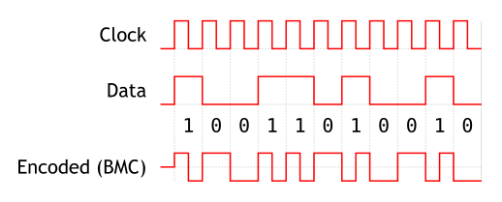

Figure 1 Biphase Mark Coding

BMC has these advantages because the signal transitions at least once for every bit:

* It is every easy to determine when a new bit arrives.
* A constant low or constant high signal means that there is no data being transmitted.
* There is frequency tolerance in reading the signal. The beacon and the receiver do not need to read/send at the exact same frequency to transmit data reliably.

These benefits increase the reliability of the transmitted data and allow for transmission up to 1000 bits per second between a beacon and a single IR receiver using Intel Edisons. Quick transmission is crucial for moving systems such as robots where the data must be transmitted before the robot moves out of way or out of line of sight.

# IR Beacon

**Hardware Assembly**

The IR LED used to transmit data is the Vishay CQY36N which can be used with high current pulses and emits light in a wide angle (angle of half intensity is 110 degrees). Six LEDs in a circular pattern is enough to cover 360 degrees laterally.

Below, please find the circuit for the IR beacon transmitters. The circuit consists of IR LEDs being driven by an amplifier composed of BJTs. When assembling this circuit, be mindful of the anode (+) and cathode (-) of the IR LEDs. Because the PWM output through the GPIO block is extremely weak in supplying current, we connect it to an emitter-follower which acts as a voltage buffer, and then that is connected to a common-emitter switch.

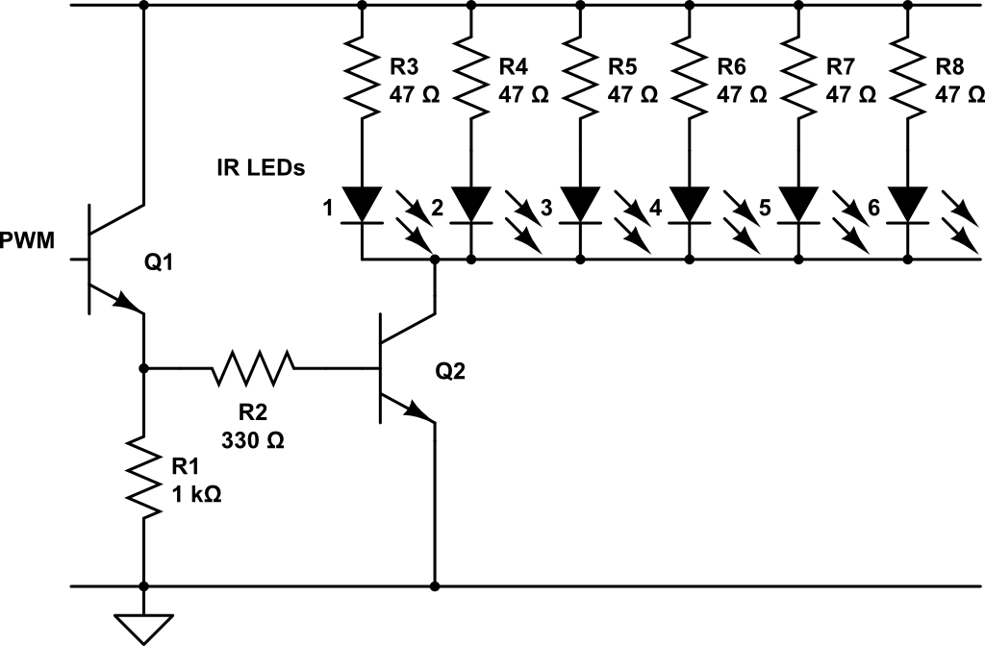

Figure 2 - IR Beacon Transmitter Circuit

Transfer the above circuit onto a small (4cm x 6cm) perfboard. Arrange the LEDs in a circular pattern, as shown below. It is good practice to first assemble this circuit on a breadboard for testing, before heading over to the soldering station. When making the circuit on the perfboard, exposing the power, ground, and pwm signals via male header may make it more convenient to handle the beacons in the future.

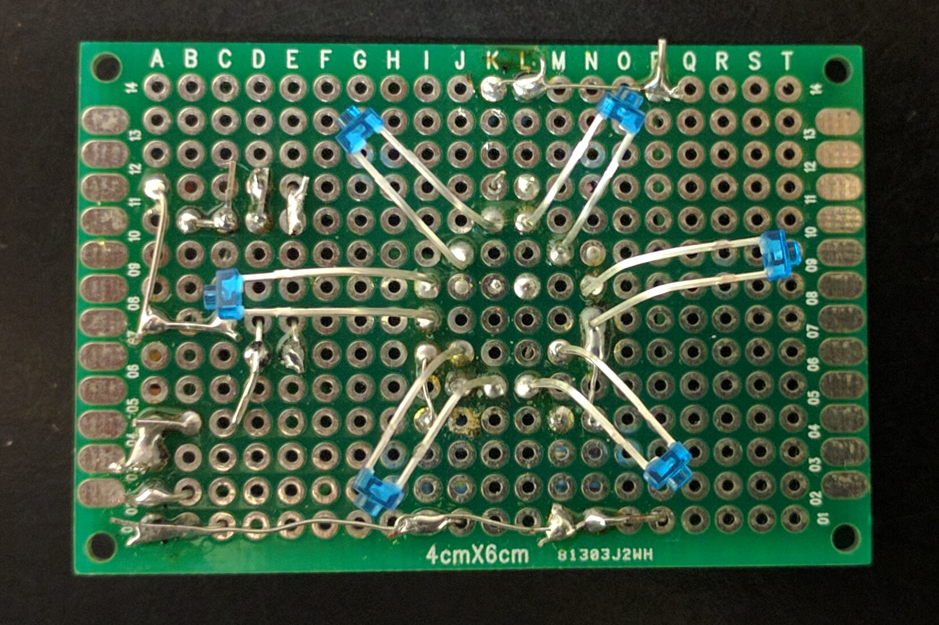

Figure 3 IR Beacon Transmitter Assembled – other components have been soldered to the underside of the board

Once the circuit is assembled, ground, pwm, and power must be connected to the GPIO block of the beacon Edison. Connect ground of the LED circuit to GND on the GPIO block, power to VSYS, and PWM to GP13/PWM1. This may be done by soldering wires to a header if you have soldered the corresponding header onto the IR LED circuit, or soldering wires directly between the IR LED circuit and the GPIO block.

For testing purposes it may be possible to use a Sparkfun Battery Block. However, to scale up to many beacons, a more economical option would be a 4-AA battery holder with 3-AA batteries and the last battery position shorted. This is because the allowable Edison input voltage (VSYS) is from 3.15V-4.5V. Using 3-AA batteries gives exactly the higher limit of 4.5V. Using 4AA batteries would exceed give 6V which exceeds the allowable Edison input voltage and could potentially cause damage to the Edison. These batteries were connected to the VSYS and GND on the GPIO block as follows (VSYS and GND will have two sets of wires soldered to them, one for the battery and one to power the beacons):

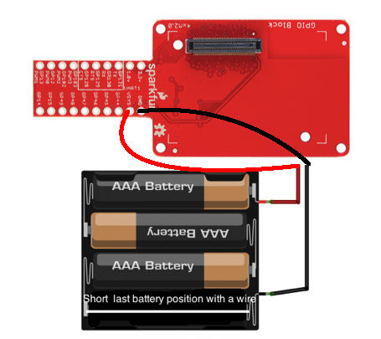

Figure 4: Battery holder and batteries configuration used to power the beacons

**Program Loading**

1. Obtain the code by visiting <https://github.com/zhgary/UCLA_EE180D_Robot/tree/master/beacon_sender> and downloading all files into the beacon Edison **into the home directory of the root account**.
2. A makefile is included to speed up the process of loading the program on multiple beacons. Use **$ make** to compile the code.
3. To start the program manually, execute **$ ./beacon_sender XX** where “XX” is a two digit hexadecimal number. The beacon will repeatedly transmit this number as a one byte character. To configure the Edison to automatically transmit when it boots, edit the file “startup.sh” to set the hexadecimal number, then execute **$ make install**.
4. There is no direct method to verify that the IR LEDs are properly transmitting. A digital camera viewing the IR LED may detect a purple glow if the LED is transmitting, but newer cameras are less likely to detect IR.
5. Optional: if you would like to test sending multiple characters, obtain code from <https://github.com/zhgary/UCLA_EE180D_Robot/tree/master/32bit_sender>. Compile with the command **$ gcc -lmraa send_signal_7.c -o send_signal_7**, and execute with **$ ./send_signal_7**. The program will prompt you for a 4 character input, then send it 10 times.

**Software Overview**

To implement BMC we have a “switchState” function which transitions the output signal from low to high or high to low depending on the current high/low state of the signal.

int switchState**(**int state**,** mraa_pwm_context pwmPinContext**)**

**{**

state **=** **!**state**;**

mraa_pwm_write**(**pwmPinContext**,** 0.5**\***state**);**

**return** state**;**

**}**

The switchState function will turn on the IR LEDs by setting PWM duty cycle to 50% or turn then off by setting duty cycle to 0%. Note that enabling/disabling the PWM device, rather than setting duty cycle to 0%, is less noisy but much slower.

To transmit BMC, we iterate through each bit of a single byte to be sent and call switchState once for 0 bits and twice for 1 bits.

**for(**k**=**0**;** k**<**8**;** k**++){**

sendBit**=** **(**pattern **>>** k**)** **&** 1**;**

**if(**sendBit **==** 1**){**

previousState**=**switchState**(**previousState**,**pwm**);**

usleep**(**halfPeriod**);**

previousState**=**switchState**(**previousState**,**pwm**);**

usleep**(**halfPeriod**);**

**}**

**else{**

previousState**=**switchState**(**previousState**,**pwm**);**

usleep**(**2**\***halfPeriod**);**

**}**

**}**

Note that for multiple bytes, another loop may be needed to cycle through the bytes.

To complete the protocol, we add a start signal (beginning of data transmission) and an end signal (end of data transmission). The default state of the signal when not transmitting will be low. The start signal is a pulse that is 4 cycles or bits long. The end signal involves not transitioning the signal for two bit cycles followed by one last transition. The IR LED can then be turned off.

# IR Receiver Array Assembly

**Circuit Representation**

This circuit is valid for the Vishay Semiconductors TSOP382 IR receiver. Please be mindful of the pin arrangement on this receiver. Please also keep in mind that different models of IR receiver will behave differently to different stimuli. The TSOP382 IR receiver will output “low” in the presence of a 38 KHz IR signal, and “high” in the absence of an IR signal. Keep these in mind when writing code to interpret IR signals.

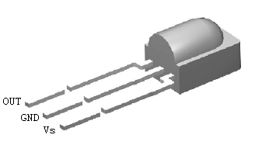

Figure 5 - IR Receiver

The circuit for an array of receivers is seen below; each long rectangular component is an IR receiver with its three pins. It is possible to add however many receiver units as the Edison can support. However, for the purposes of building the **pathfinding robot**, an array of 6 IR receivers is used to provide a compromise between data transfer rate, detection of IR beacon direction, and pin occupancy on the Sparkfun GPIO block.

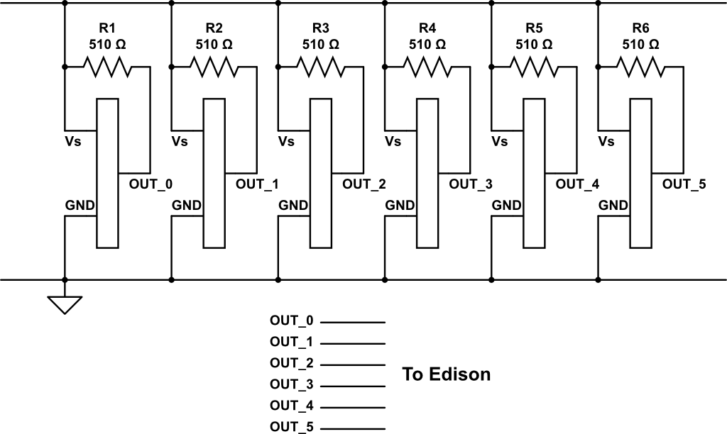

Figure 6 IR Receiver Circuit

**Circuit construction**

1. First, construct the above circuit. It is recommended to first build this on a breadboard for easier debugging, and then move on to a perfboard. Using headers or connectors is also recommended when moving onto a perfboard. The assembled circuit is seen in the next figure. The array of receivers may be arranged in any way, but the photograph shows the correct arrangement on a 4x6 cm perfboard if you wish to build the **pathfinding robot**.

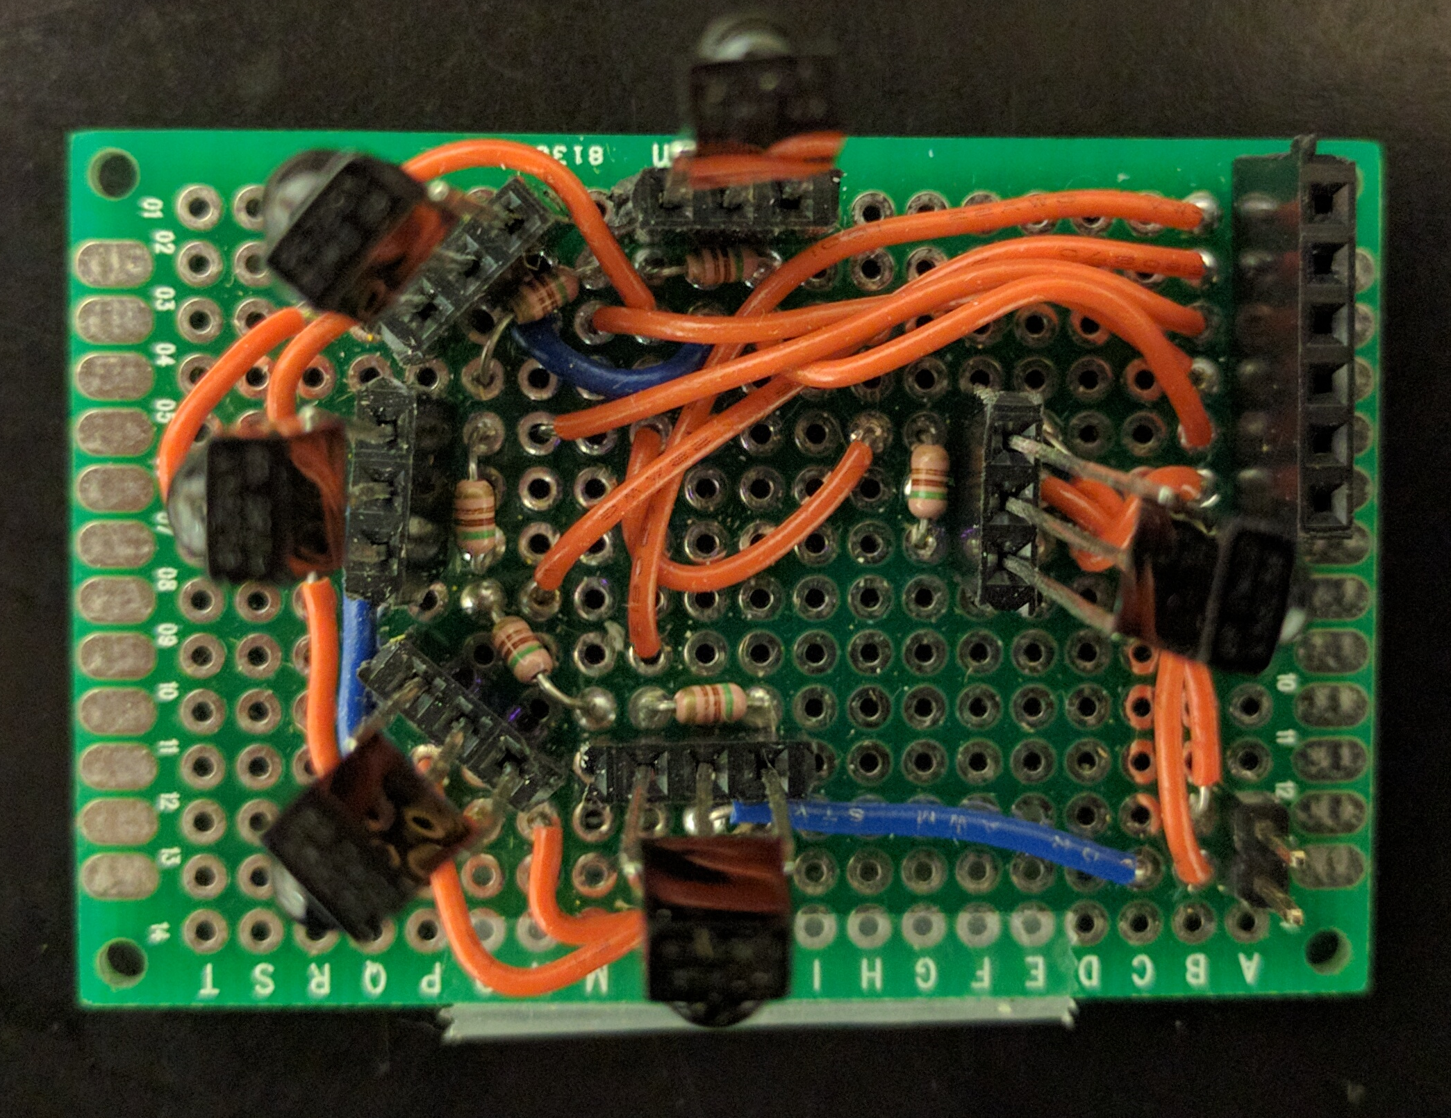

Receiver 0

1

2

3

4

5

Front of robot

Figure 7 IR Receivers Assembled

1. To improve the directional detection for the receiver array, slip cardboard between the receivers as such:

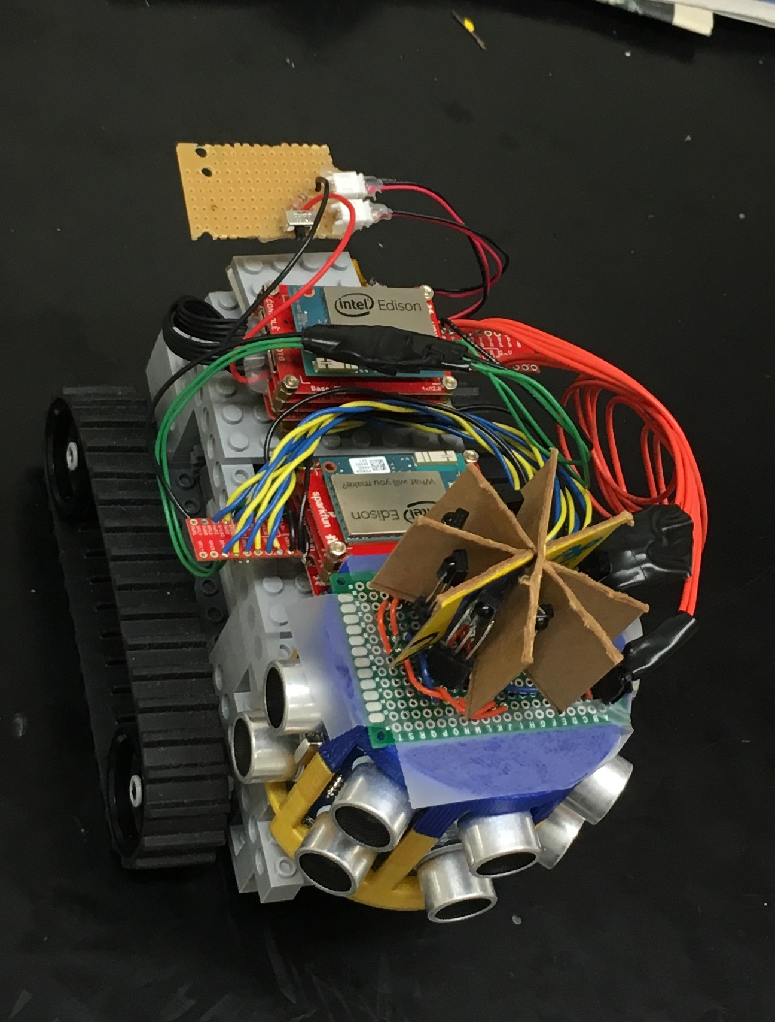

Figure 8 IR Receivers Separation

1. Now the Sparkfun GPIO Block must be connected. First, the level shifter on the GPIO Block must be configured to VSYS by resoldering a jumper on the GPIO block.

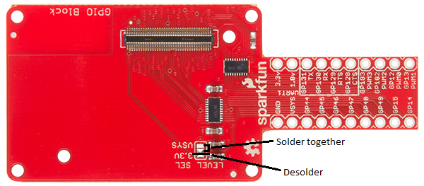

Figure 9 Level Select on Sparkfun GPIO Block

1. Solder wires to the GPIO according to the following connection scheme:

* Vs on IR circuit to VSYS on GPIO block
* GND on IR circuit to GND on GPIO block
* OUT_0 to GP129
* OUT_1 to GP128
* OUT_2 to GP183
* OUT_3 to GP44
* OUT_4 to GP45
* OUT_5 to GP46

1. Stack the Edison, Base Block, GPIO Block, and Battery Block. Connect to the Edison via the CONSOLE micro-USB receptacle on the base block.

# IR Receiver Array Software

**Demonstration**

1. Obtain code from here: <https://github.com/zhgary/UCLA_EE180D_Robot/blob/master/IR%20Receiver%20Array/read_signal15.c>
2. Compile with this command: **$ gcc -lmraa read_signal15.c -o read_signal15**
3. Execute with this command: **$ ./read_signal15**
4. Watch the text terminal. The program will collect two beacon transmissions and compare them for a match.

**Overview**

With a single IR receiver, it is possible poll the receiver and record data by interpreting the timing of transitions until the end signal appears and then process the collected data (this will be left to the reader). This is not the case when monitoring multiple receivers. For multiple receivers, a program must poll every receiver, keep track data and the state of multiple receivers, and deal with the possibility that data transmission ends on one receiver while another receiver is in the middle of a data transmission.

For monitoring multiple IR receivers with the Intel Edison, it is best to use a single thread to poll IR receivers in a round robin fashion. It is possible to use multithreading with one thread for each receiver, but there are a few problems. If the threads use interrupts, then the software is slow due to the overhead from the MRAA library and the Linux operating system. If the threads poll the receivers, the Edison’s processor only has two cores and it is not possible to guarantee frequent switching between threads and equal time spent monitoring. In addition, running the IR receiver code on a single thread/core leaves the other core available to perform other tasks such as motor control, as is the case with the **pathfinding robot**.

The code for monitoring the IR beacons is structured as such in the figure below:

Green box = function

Yellow box = hardware input

Orange box = data storage or variables

Black arrow = data flow

Red arrow = function call

wait_for_next_transition

wait_for_next_sequence

receiverLoop

Receivers

data

Figure 10 IR Receiver Monitoring Code Structure

wait_for_next_transition is the function that, when called, round robin polls each receiver until a rising or falling edge occurs. Then the function returns to its caller. This caller is the wait_for_next_sequence function. The wait_for_next_sequence function repeatedly (1) waits on the wait_for_next_transition function, (2) interprets the timing of the rising or falling edge and (3) writes to the data buffer corresponding to the receiver on which the event occurred, until a signal signaling end of data transmission occurs on one of the receivers. At this point, wait_for_next_sequence returns to its caller, receiverLoop, signaling that data is available for one of the receivers. receiverLoop must process this signal as quickly as possible before calling wait_for_next_sequence again, so that data reception for other receivers is not interrupted.

Furthermore, data processing is further complicated by two things: error checking and multithreading. For error checking, the code makes sure that the data has not been corrupted by comparing two consecutive data transmissions. For multithreading, the IR receiver thread cannot write to a data buffer that another thread is reading from. To deal with these two issues, the receiver thread, in the receiverLoop, maintains a set of three data buffers for each IR receiver. A few more state keeping variables are added: a “consumer” pointer that specifies which of the three buffers, if any, that the other thread is currently reading, and a “producer” pointer that specifies if new data, contained in a different one of the three buffers, is available. With three buffers, one buffer is available for the consumer to read while the two remaining buffers allow the receiver thread to do a comparison between two beacon transmissions.

data

Receiver 0

Buffer 0

Buffer 1

Buffer 1

...

Receiver 1

Buffer 0

Buffer 1

Buffer 1

Receiver 2

Buffer 0

Buffer 1

Buffer 1

Figure 11 Multiple Buffers per Receiver

The below diagram illustrates an example of data processing. Note that this process effectively occurs simultaneously for all receivers.

Consumer is reading from buffer 1,

Receiver writes to buffer 0

data

Receiver 0

Buffer 0

11..

Buffer 1

1010

Buffer 2

1010

receiver

thread

receiver

thread

consumer

thread

receiver

thread

Consumer continues to read,

Receiver writes to buffer 2

data

Receiver 0

Buffer 0

1100

Buffer 1

1010

Buffer 2

11..

receiver

thread

receiver

thread

Consumer finishes reading,

Receiver compares buffers 0 and 2

data

Receiver 0

Buffer 0

1100

Buffer 1

1010

Buffer 2

1100

receiver

thread

receiver

thread

consumer

thread

receiver

thread

Receiver signals consumer to read buffer 0, Receiver writes to buffer 1

data

Receiver 0

Buffer 0

1100

Buffer 1

00..

Buffer 2

1100

receiver

thread

receiver

thread

consumer

thread

receiver

thread

Figure 12 Possible Data Processing Flowchart

# References

1. <http://iotdk.intel.com/docs/master/mraa/edison.html>
2. <http://man7.org/linux/man-pages/man2/gettimeofday.2.html>
3. <http://iotdk.intel.com/docs/master/mraa/gpio_8h.html#a8570d9f7a4ec0c568a727f7dda14cb82>
4. <https://www.sparkfun.com/products/13038>